VHDL Assignment 2

|  |  |  |  |
| --- | --- | --- | --- |
| Student 1 name: | ID number | Student 2 name: | ID number: |
| Yutong Wang | 260839723 | Hongtao Xu | 260773785 |

1. Explain your VHDL code

* Task 1: As shown below the Canonical SOP expression was derived from the truth table. Then the function was implemented using direct assignment.

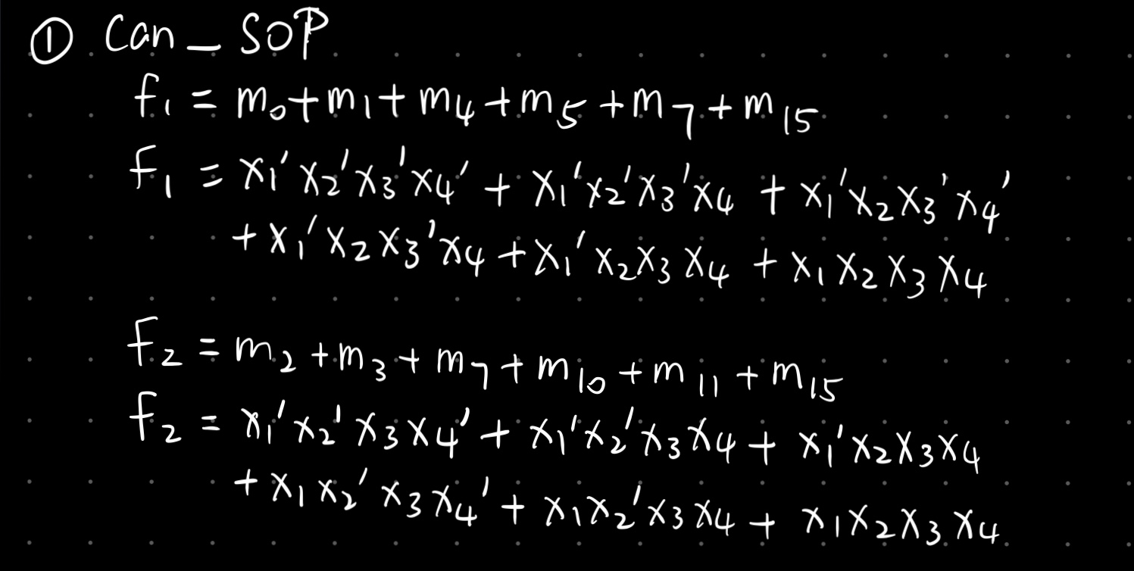

* Task 2: As shown below the Canonical POS expression was derived from the truth table. Then the function was implemented using direct assignment.

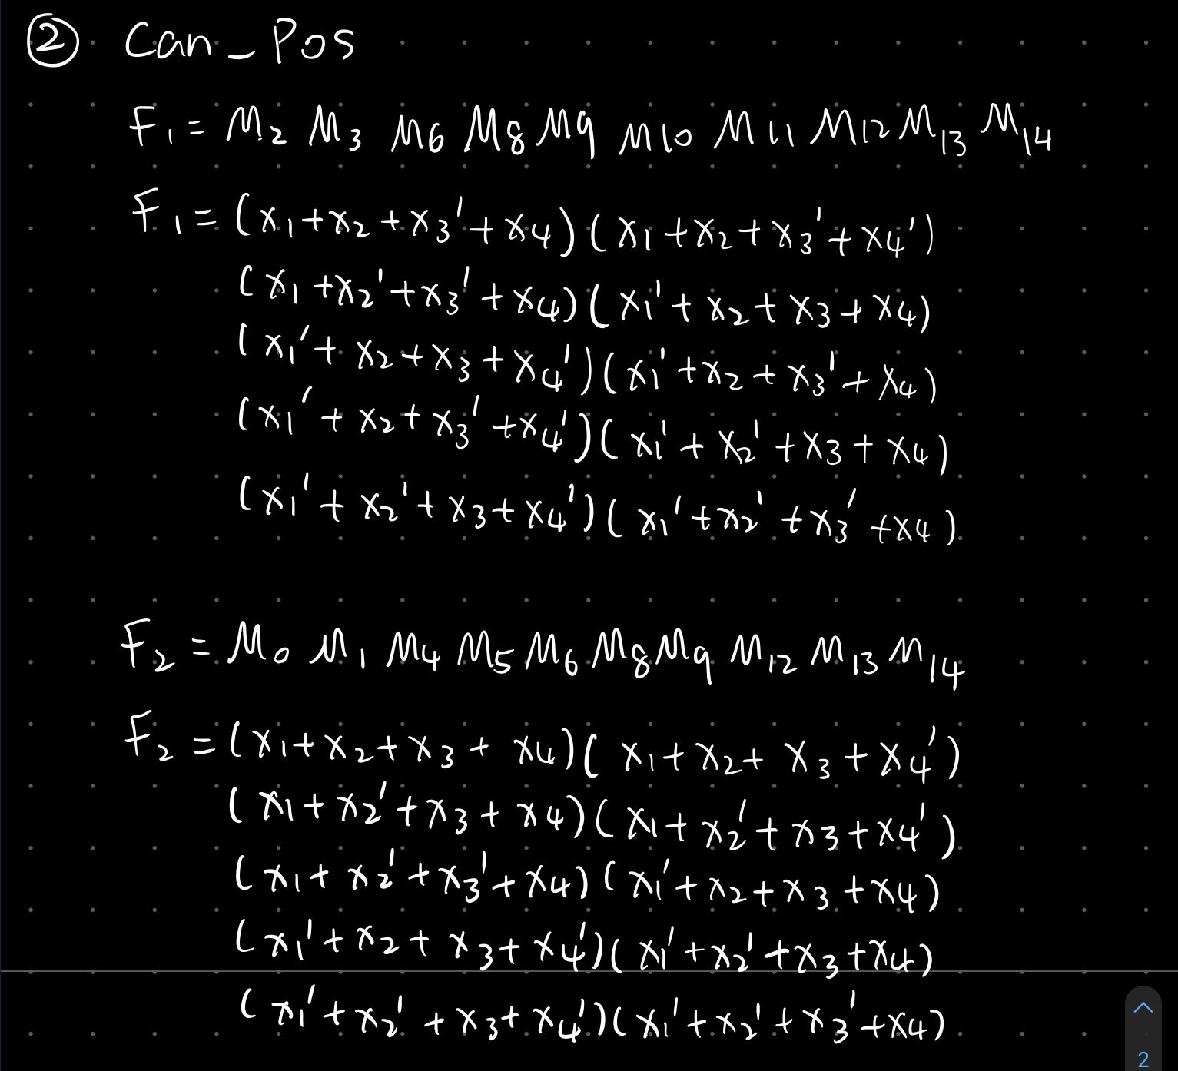

* Task 3: As shown below, K-map was used to obtain the simplified expression of SOP. Then the function was implemented using direct assignment. 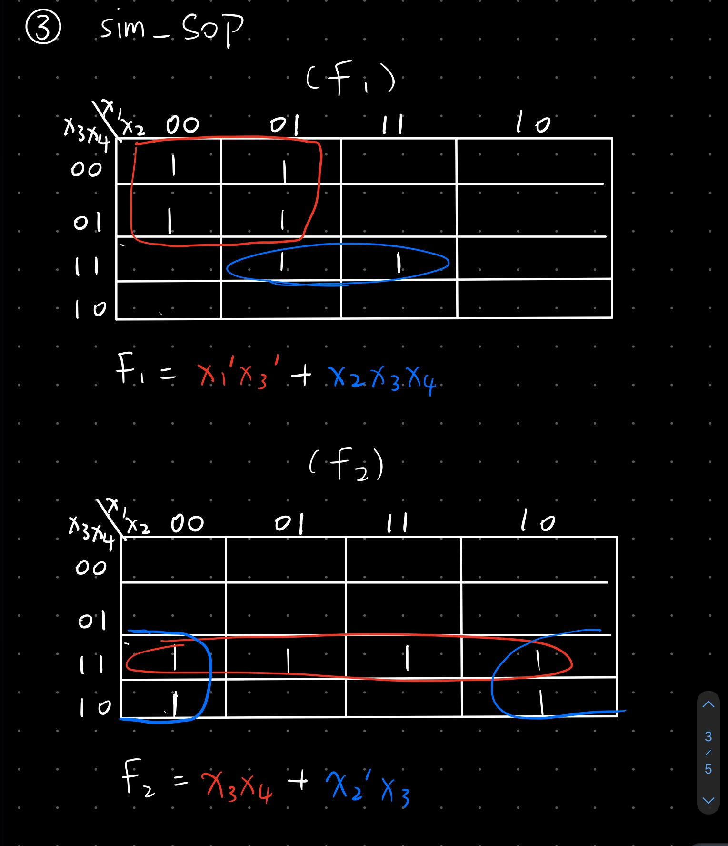
* Task 4: As shown below, K-map was used to obtain the simplified expression of POS. Then the function was implemented using direct assignment

.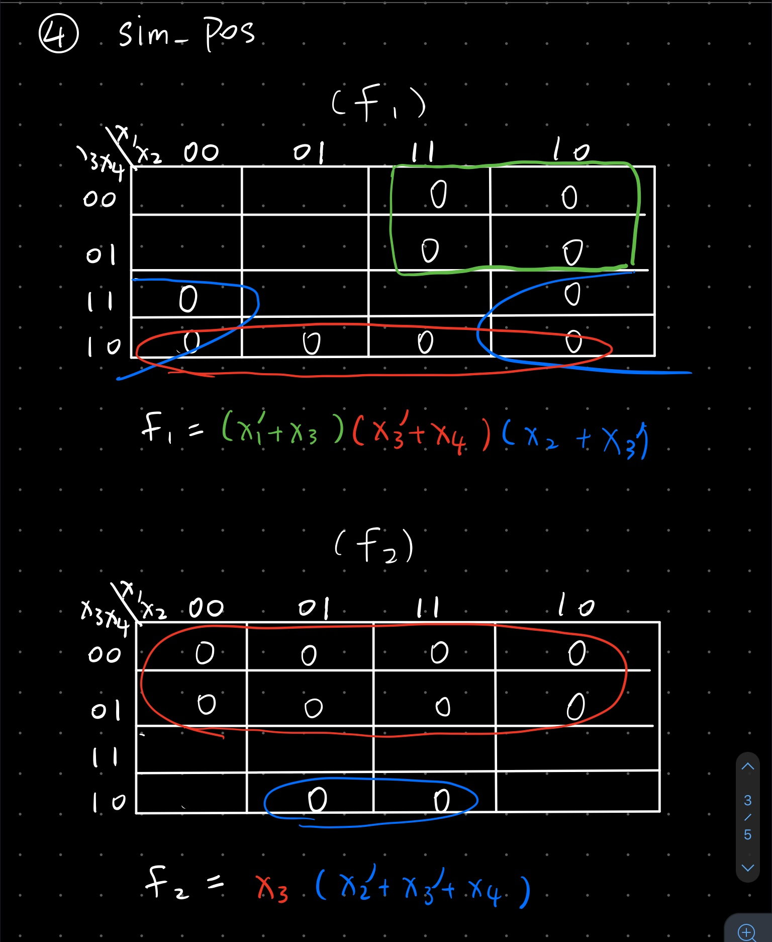

* Task 5: From the truth table, there are 4 times of input values generating output f1f2 as “10”: row 0,1,4 and 5. And 4 times of input generates output as “01”: row 2,3,10 and 11. Also, 2 times generating “11”: row 6 and 15. The remaining 6 rows generate output as “00”.

By using Select/With statement, we can group those inputs which generates the same combination of output respectively and quickly. It is the value of control expression compared with n possible options, “when” a match is found, the value for the option would be assigned.

* Task 6: From Task 5, we know that there 4 groups of inputs generating the same combination of output. This time we use When/Else statement to group them. It is different from groups combination, which means that each arrangement of input has its own value to correspond. This is the expressions after “when” are evaluated consistently until a true expression found. The last assignment would be evaluated if none of true expressions found before. The earlier evaluated expression has a higher priority.
* Task 7: We found that the most joint-optimized SOP to represent F1 and F2 is the arrangement we have on Task3: Diagram

  Description automatically generated

2.

|  |  |  |  |  |  |  |  |
| --- | --- | --- | --- | --- | --- | --- | --- |
| Task | 1 | 2 | 3 | 4 | 5 | 6 | 7 |
| Cost | 82 | 82 | 24 | 24 | N/A | N/A | 24 |
| Logic Utilization (in LUTs) | Used:2  Avail:63400 | Used:2  Avail:63400 | Used:2  Avail:63400 | Used:2  Avail:63400 | Used:2  Avail:63400 | Used:2  Avail:63400 | Used:2  Avail:63400 |

1. Show representative simulation plots of all tasks for all the possible input values (exhaustive test results).

* Task 1 can_SOP:

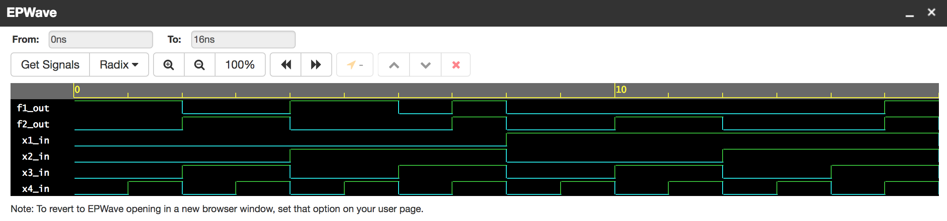

* Task 2 can_POS:

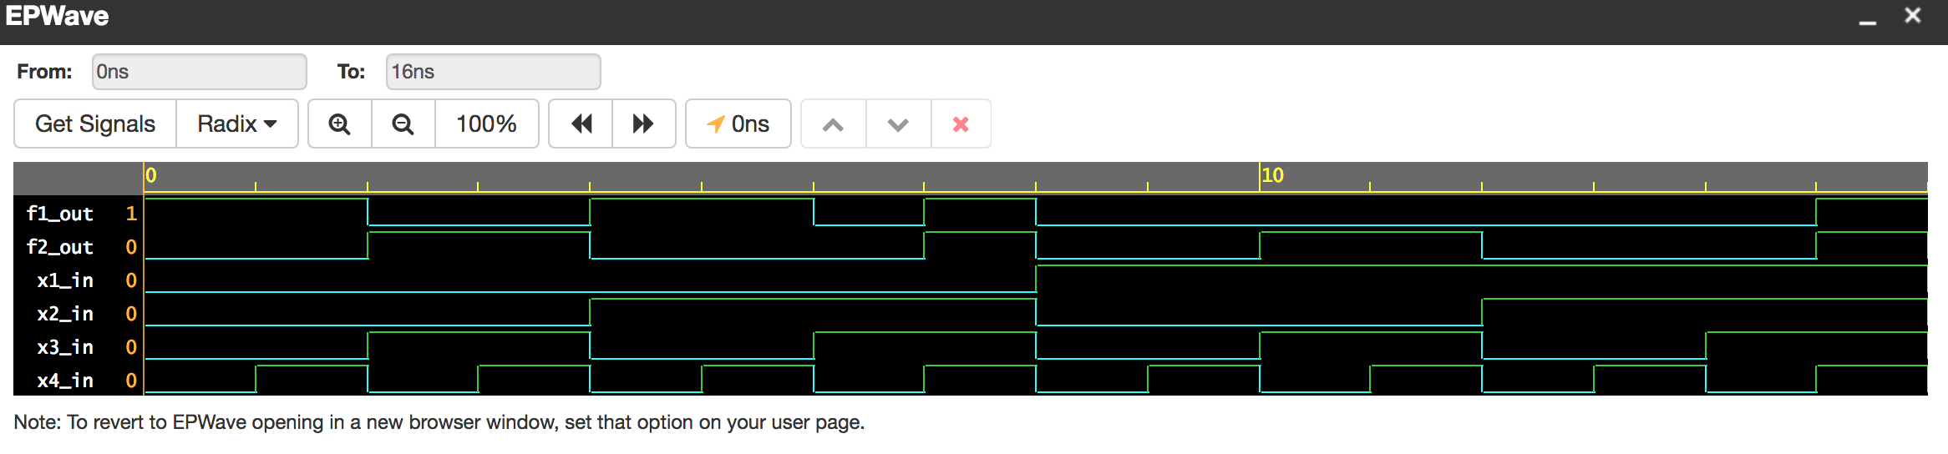

* Task 3 sim_SOP: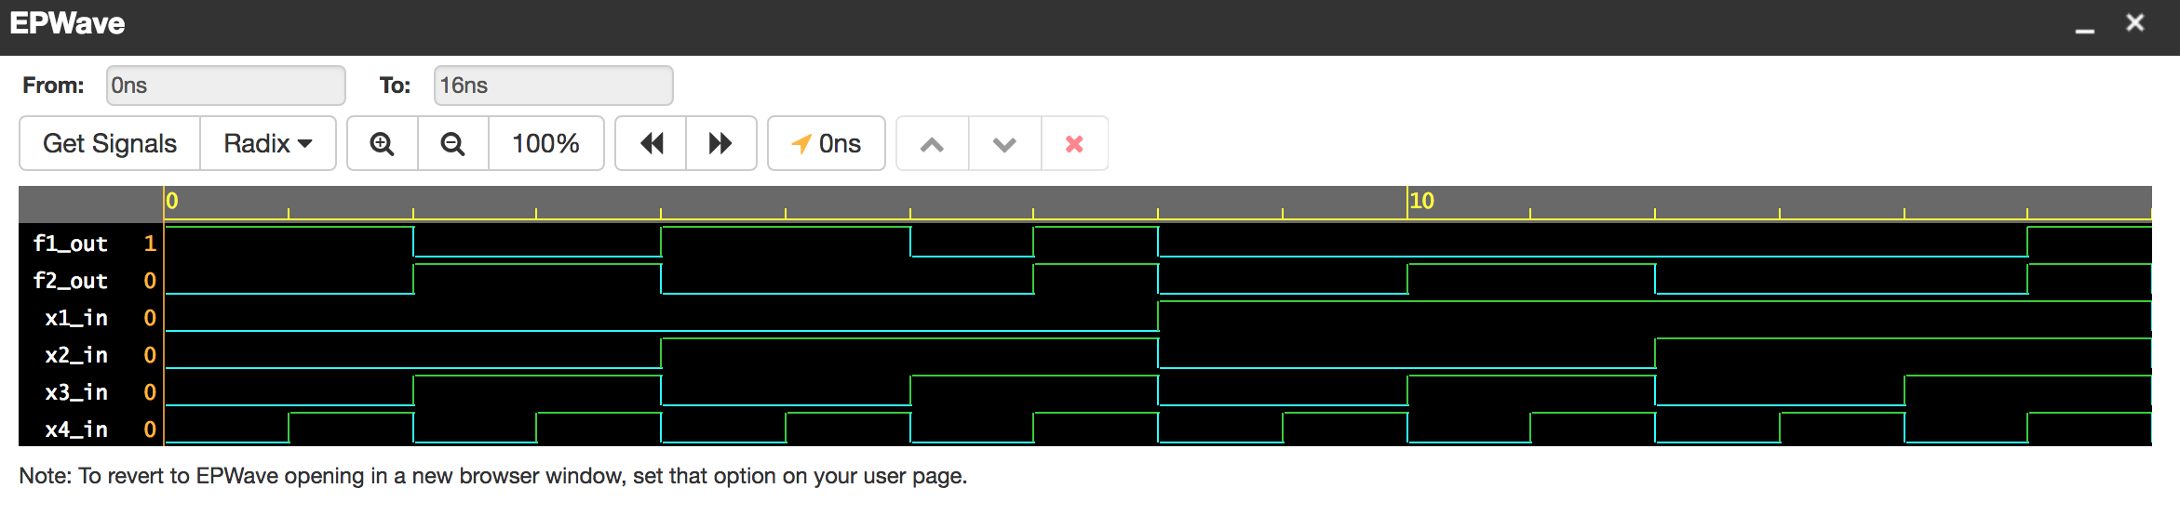
* Task 4 sim_POS:

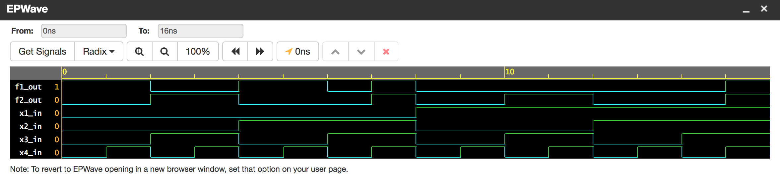

* Task 5 select_assignment:

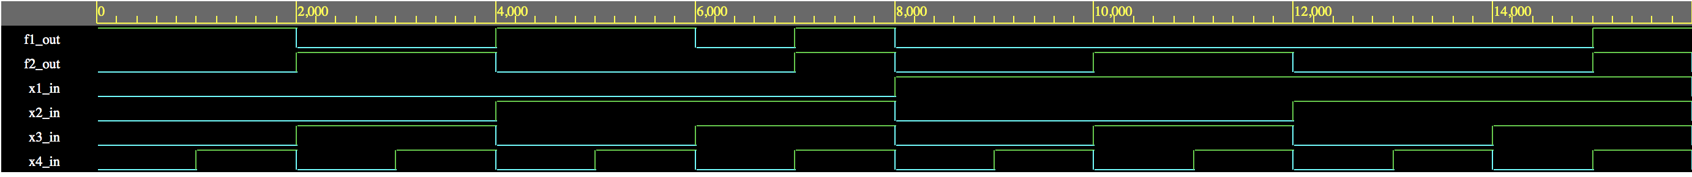

* Task 6 when_assignment:

* Task 7 joint_SOP:

